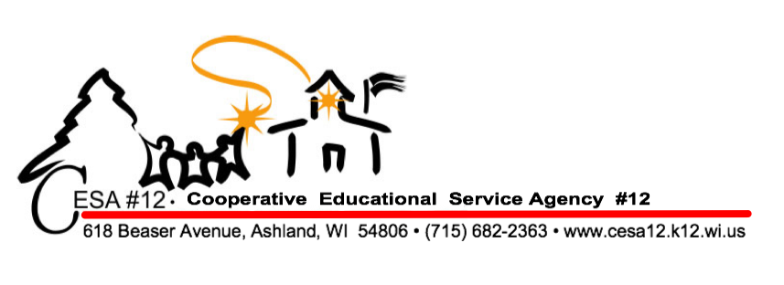

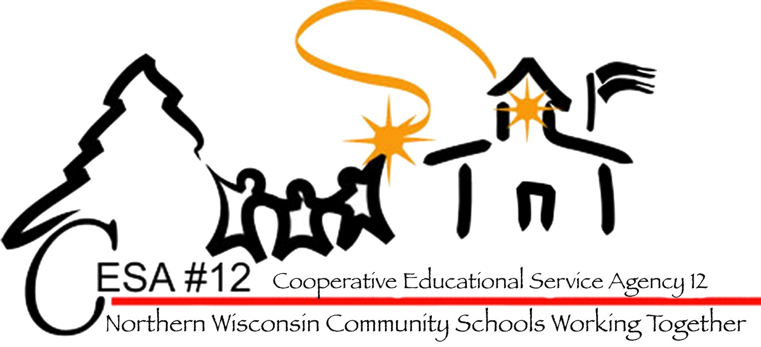

Advancing Systems, Beliefs and Skills to Support Behavior
Wisconsin State Performance Standards Addressed
Wisconsin Teacher Standards Addressed: 2, 3, 4 ,5
Wisconsin Pupil Services Standards Addressed: 6

Registration Fee: $20.00

(Registration fee includes materials, break and lunch)

Viterbo credit available

Register: myquickreg.com

This interactive workshop will provide attendees with an opportunity to advance their practice of supporting student behavior from three critical perspectives:

The system level, in which we identify how behavior supports fit within our current MLSS (multilevel system of support) framework(s) and examine the environmental context in which behavior occurs

The belief level, in which we evaluate the beliefs necessary for advancing student outcomes

The skill level, in which we explore strategies to support the social-emotional learning and behavior of our students

Tuesday, January 16, 2018
CESA #12 Conference Center
Registration: 8:30 a.m.
Conference Time: 9:00 a.m. – 3:00 p.m.

Presenter: Jessica Nichols –
Education Consultant, Wisconsin DPI

